UNM CDD Autism and Other Developmental Disability Program: The Autism Spectrum Evaluation Clinic (ASEC)
The Autism Spectrum Evaluation Clinic provides comprehensive interdisciplinary diagnostic evaluations for Autism Spectrum Disorder (ASD) and/or related and co-morbid conditions. We are one of the few approved providers for Medicaid, and the only interdisciplinary autism evaluation team in the state of New Mexico
Our ASEC Program:
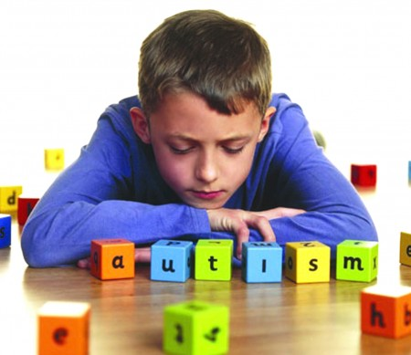
- We serve children ages 3 and older and their families from every region of New Mexico.
- Fast-paced 4-6 hour evaluations, including a caregiver interview as well as formalized assessment tools to evaluate social and emotional development, communication, thinking and problem solving, adaptive skills and behavior.
- We are supported by the New Mexico Department of Health
- We have metro clinics in Albuquerque, and also have outreach clinics (the team travels) in remote parts of the state to serve rural communities and families for whom travel to Albuquerque is not possible.
- Our interdisciplinary teams have strong expertise in ASD and developmental disabilities and include a pediatrician, clinical psychologist, speech-language pathologist and clinical social worker. Trainees from different fields and training programs often observe and participate in clinics.
- No out-of-pocket expenses for the families for ASEC evaluations as Medicaid or private insurance are billed for evaluations.
Statistics or Characteristics of the population served at the clinic
% Medicaid; age; gender; % diagnosed with ASD [pull stats for ASEC]; other diagnoses – we know families in NM are impacted by a significant number of ACEs.
Post-Evaluation Services:
- Help families find resources for their child, including recommendations for treatment, necessary follow up evaluations.
- Referrals to other services in the Autism Programs at the CDD as well as in the community.
Examination of Adversity in our Program:
- Since ASD diagnosis is the focus, teams spend time gathering specific information about early developmental history and autism-specific concerns.
- Unless prior documentation exists, a child’s or family’s history of adverse life events and toxic stress is not necessarily quickly revealed on the day of a fast-paced, intensive evaluation session.
- Our clinical interview with the family asks directly about experienced events of abuse specifically related to the child but does not typically delve into issues regarding domestic violence, household substance abuse or parental incarceration unless it has already been revealed. Information regarding marital status and family mental health history is collected as part of the intake procedure and then confirmed in the interview.
- Considering the role of adversity in a child’s clinical presentation in ASEC is a newer perspective.
Issues/ dilemma encountered
- An autism diagnosis can be derailed by a consideration of the impact on adverse life events on a child’s development.
  - What symptoms or behaviors can be attributed to autism and which are the result of adversity and toxic stress?
  - Where is the intersection of autism and adversity and what does this look like clinically?
- Often, differential diagnoses must be considered as adversity has significantly impacted development and the child is now dealing with mental health issues.
- Because of stressful family experiences, delays or barriers may exist in accessing timely diagnostic evaluations and treatment of ASD.
Next Steps
- Training around impact and developmental sequelae of adverse events on children to better understand clinical presentation and differential diagnosis.
- Implement systematic way of gathering information about adverse life events and traumatic exposure prior to and day of evaluation.
******************************************************************************
[As a state, our total population is just under 2.1 million people. Children under the age of 18 make up 24% of the population. That is approximately 500,000 children. 30% of children under the age of 18 are living in poverty, 16% are living in what are considered unsafe communities, 28% of children have experienced two or more adverse experiences including economic hardship, parental death, parental incarceration, family violence, neighborhood violence, living with someone struggling with addiction. 19% of children lived in households that did not have enough food at some point during the year. CYFD reported that there were 15, 836 accepted reports of abuse and/or neglect in the calendar year 2009. Of these, 4,846 were substantiated. That means one out of every 116 children from around the state that has experienced a substantiated incident of abuse and/or neglect. The National Coalition Against Domestic Violence reported that in 2006, 3,892 children were present at the scene of family violence episodes in New Mexico. 54% of these children were 12 years and under. According to domestic violence service providers, 21% of child victims or witnesses in New Mexico also experienced physical abuse and 5% experienced sexual abuse. 56% of adult domestic violence victims and 59% of their offenders in New Mexico report that they were abused as children. In 2010, the National Center of Family Homelessness reported that there were 1,600 homeless children in the state of New Mexico. These children suffer from hunger, poor physical, mental and emotional health and missed educational opportunities.]

